The function 1.6 Item browse. We put in the filter Status = N and select all records. We download to excel, and we will upload 2 functions 1.4.1 (maintenance of items) and 1.4.15 (standard costs)
The columns that are important, and we will need them. - Item number, Unit, Description 1, Description 2, status, product line, revision
CIM file for 1.4.1 and copy the columns:
Item number - we are not changing anything.
Unit - it is needed change according to your language from Czech language.
Description 1 – the same situation – it is needed translated do your language.
The columns „english“ will help you
Description 2 is mostly a dimension, we don't change that
Product line - we are not changing anything
Status – everywhere OK
Group - this is related to sales price lists. Let's add for example AXXAXX, if it is gold decor (top seller) it is GXXGXX. This concerns the edges that are in the collection 1010, 1110, 1210. It is individually for each Branch
Revision - it is information about surface, Abbreviation in your language
Deposit – H articles
This is all the data I'm putting into function 1.4.1
UPLOAD CIM to QAD activate the program Total commander
- click to FTP and first try it in the MODEL
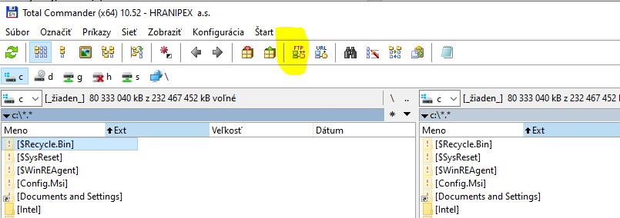
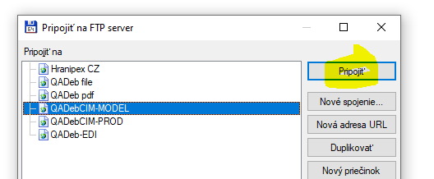
- then when everything is OK, do the same procedure only you connect to PROD
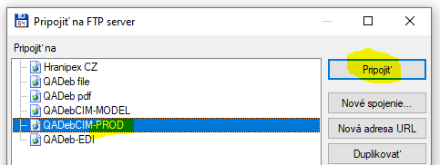
- In the right part you can search for the name of the file, according to where you have it saved and sort by date, so you can see the file on the top
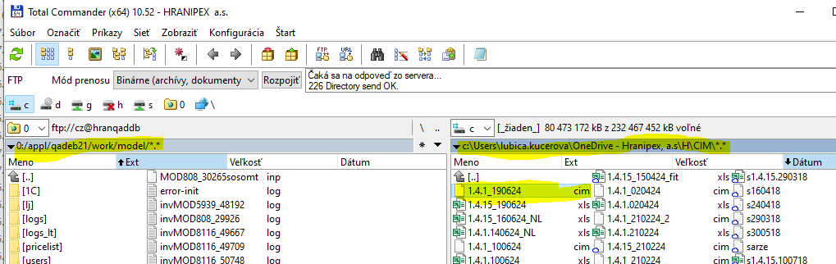

- Copy to left part
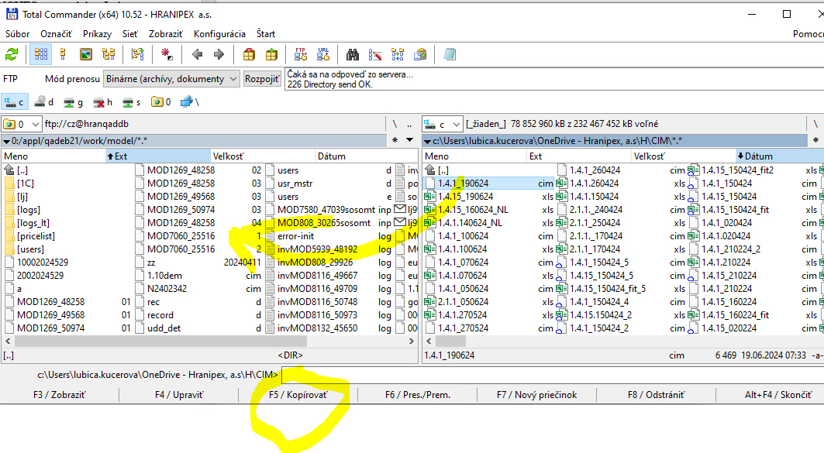
- Ctrl C
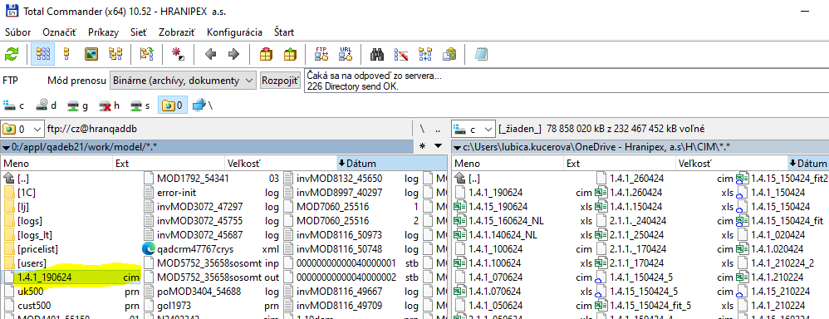
- go to the function 36.15.1
CTRL V, enter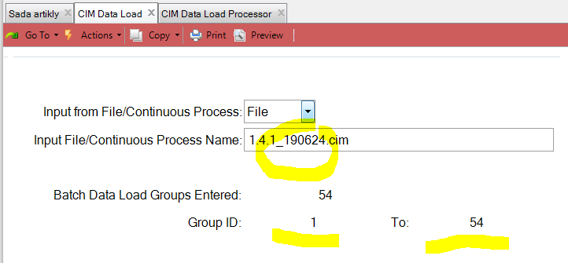
Group ID is important because it is need paste to the function 36.15.2
- go to the function 36.15.2
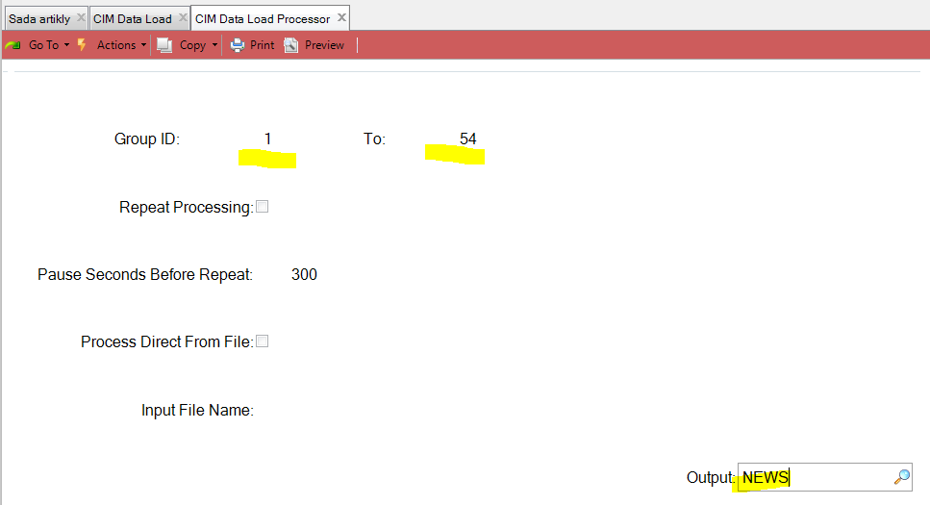

The name of output is up to you.
- go back to Total commander and refresh and search output, in my case NEWS
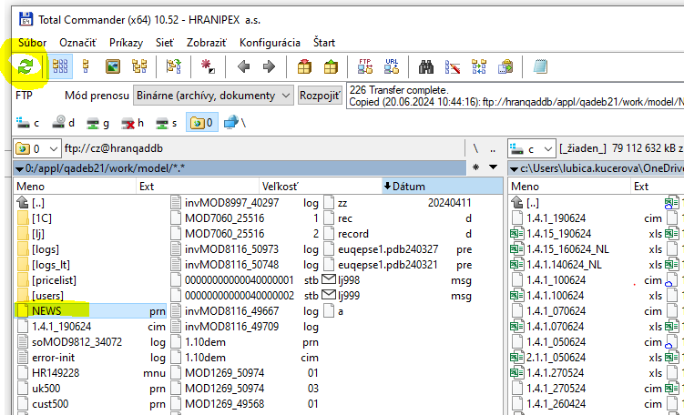

Click to F3 and check output
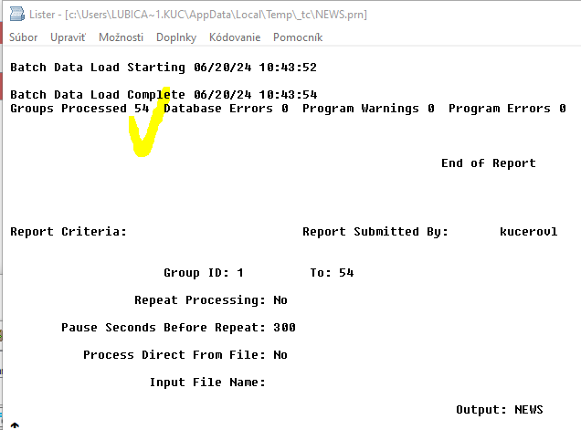
- Then I will check in 1.4.1 on some items if everything is right
CIM file for 1.4.15 and copy the columns:
- There we need only the items that have purchase price. Because the purchase price must be equal to the standard cost
- We need Item number and purchase price only
- Regarding fittings we have OK status only for those items where we have the purchase price.
The way to upload to qad is the same as for Cim 1.4.1

